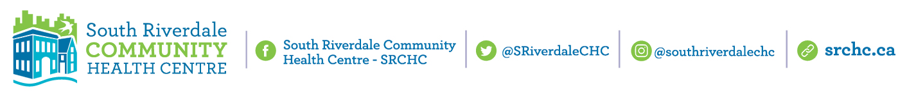

**South Riverdale Community Health Centre (SRCHC) Fact Sheet**

**SRCHC at a Glance**

* SRCHC has been offering comprehensive primary health care and social supports in the South Riverdale community since 1976.
* Today we have over 200 staff who work at our 5 locations.
* SRCHC had an annual budget of $22 million in 2022. Our finding is diversified with 56% from Ontario Health and 16% from the Ministry of Health.

**SRCHC Service volumes**

* We provide services to 14,500 registered clients and over 100,000 client visits.
* During the pandemic we geared up to help address food security. Last year SRCHC served 20,000 meals to community members.
* SRCHC’s COVID response work included low barrier clinics and mobile vaccination, providing more than 3,500 first, second, and third doses of COVID-19 vaccine in our local community.

**Primary Integrated Care**

* Team based primary care is provided to over 5,000 registered patients who have access to doctors, nurse practitioners, midwives and nurses who provide care to individuals and families.
* We also have a team of allied health professionals including, social workers, chiropodists, physiotherapist, dietitians and health promoters.
* People come for preventative care, infant and maternal care, help with managing chronic diseases and other important primary care services.

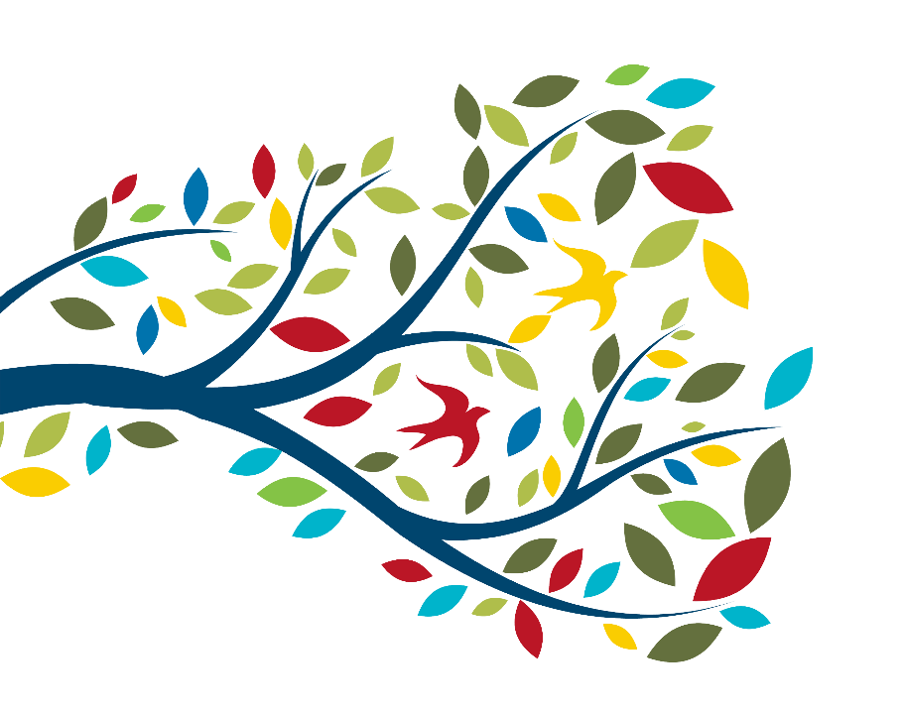

**Health Promotion**

* We offer health promotion programming for seniors and families that promote wellness and community connection. We also have programming to support food access and environmental health with seasonal gardening and other social programs that all make up a holistic approach to wellness.
* In 2022/23, we offered 88 group programs.



**Client Profile**

* 60% of our clients are low-income with 24% receiving social assistance.
* SRCHC’s clients come from 135 different countries, with 16% who are newcomers to Canada (arriving in the last five years).

**SRCHC Substance Use and Mental Health Team**

* SRCHC has operated one of the city’s largest and most holistic harm reduction programs in its current location since 1998.
* Harm reduction is a comprehensive set of principles and programs aimed at reducing the negative consequences associated with the criminalization of drug use.
* Harm reduction at SRCHC includes a variety of multidisciplinary, integrated programs and services for people who use drugs, including primary health care health care, needle and stem kit distribution/return, safer drug use education, naloxone distribution/training, outreach, safer supply, Hep C treatment, group programs (women’s drop-in, art, grief and loss support), practical supports (legal clinics, income assistance), Indigenous harm reduction programming.
* At least 1,250 people in East Toronto used one of the Health Centre’s harm reduction services last year with over 33,000 visits in 2022.
* The Substance Use and Mental Health Team at SRCHC made 11,762 referrals to health care and other social services in 2022. From January to July 2023, at least 165 individuals received clinical support for drug use from Health Centre providers beyond the CTS.
* In the first six months of 2023, there were 112 referrals made to addictions services (detox, treatment) and 986 made to mental health services.

**Broader Context: Overdose Numbers**

* There has been a significant increase in overdose deaths since the COVID-19 pandemic began.
* In Toronto 539 people died of an opioid overdose in 2020, up from 300 in 2019. Preliminary data suggests there were at least 511 overdose fatalities in 2021. There were 490 confirmed deaths in 2022. In May 2023 alone there were 23 fatal overdoses in Toronto.

**Consumption and Treatment Services (CTS) at SRCHC**

* SRCHC’s service is allowed to legally operate through an exemption under the federal Controlled Drugs and Substances Act (Section 56.1). The service is funded through the Ministry of Health as a Consumption & Treatment Service.
* There are just 8 other Supervised Consumption Sites (SCS) in Toronto and the CTS at 955 Queen St. E is the only supervised consumption service East of the Don Valley.



* As part of its initial exemption approval in 2017, SRCHC underwent an in-person site inspection and policy/procedure review by Health Canada.
* Exemption renewals are required after the first year of operation and then every three years if there are no concerns. SRCHC has had its exemption renewed in 2018 and in 2021.
* The service underwent and successfully passed an inspection as part of a ‘CTS Compliance and Enforcement’ protocol, mandated by the MOH and conducted by Toronto Public Health, in May 2023. [Report is now posted publicly](https://www.toronto.ca/community-people/health-wellness-care/health-inspections-monitoring/consumption-treatment-services-cts-inspection-program/).

**Consumption and Treatment Services: Impact**

* Lately the CTS has about 40 unique service users per day. In June 2023, 57 unique individuals used the CTS which has up to 100 visits per day (this fluctuates greatly from about 35 to 100).
* The CTS had over 10,000 visits for drug consumption last year and there have been over 5,000 visits in the first six months of 2023.
* CTS staff reversed 124 overdoses in 2022. Over 900 overdoses have been reversed since the service began in November 2017.
* CTS is a health care service. CTS staff also make referrals to health and social services and provide primary care to service users directly
* In 2022, CTS staff made the following referrals to health and social services:
  + 59 to substance use services (detox, treatment program, methadone, safer supply)
  + 11 referrals to mental health services (case management, treatment program)
  + 124 referrals to primary care and hospital services
  + 101 referrals to social services (Indigenous health promoter, shelter, group programs, ID replacement, legal support, social assistance support, housing)
* Preliminary data by researchers at Unity Health who are conducting the evaluation of supervised consumption services in Toronto found that the proportion of service users who participated in a drug/alcohol treatment or detox program in the last six months was significantly greater than the proportion of non-service users:
  + 53% of recent SCS service users vs. 43% of non-service users recently participated in a drug/alcohol treatment or detox program
  + 38% of recent SCS service users vs. 25% of non-service users participated in a methadone maintenance program in the last 6 months