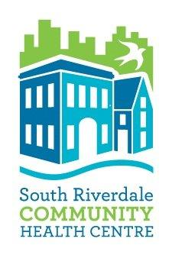
Accessible Customer Service Feedback Form
South Riverdale Community Health Centre (SRCHC) is committed to excellence in serving all clients including people with disabilities.
We welcome feedback on the services that we provide so that we can ensure that we fully respect and promote the dignity and independence of people with disabilities.
Please provide your comments below:

If you would like to receive follow-up from us about how we will respond to your feedback, please provide your preferred contact information below:
Email
Daytime phone
Address
In Person at the Centre
over…

This feedback is collected under the Accessibility for Ontarians and Disabilities Act (AODA), Accessibility Standards for Customer service. You feedback will be reviewed by the Management Team of SRCHC.
If you have requested a follow-up, we will contact you within 5 business days.
Thank you for taking the time to provide your feedback.
If you would like to contact us with any further information,
Call: 416.461.3577
Email: info@srchc.com
Write: Accessible Customer Service Feedback
955 Queen Street East
Toronto ON M4M 3P3

Additional comments:

~~~~~~~~~~~~~~~~~~~~~~~~~~~~~~~~~~~~~~~~~~~~~~~~~~~~~~~~~~
Feedback received (date): ____________________
Acknowledgement sent (date): ____________________
Reviewed by: ____________________

Form reviewed February 2017

